# Project Title: Universal Token System-Android Application

# Team Number: 04

# Total Team Members: 08

|  |  |  |
| --- | --- | --- |
| **Members Name** | **Member’s Role** | **Comments** |
| Srinivasa Rao Chatala | Developer |  |
| Vanglirajan kalimuthu | Developer |  |
| Shivani Gupta | Developer |  |
| Jasmeet Kaur Seghal | Developer |  |
| Kulbir Kaur | Developer |  |
| Evlyn Maria | Developer |  |
| Alagu Murugappan Ramanathan M | Customer/Developer |  |
| Imraan Ali | Developer | Never Showed up for any class/meetings, did not work on the project |

# **Release 01: Screenshots**

**Android Application --->**

**Validate Student:**

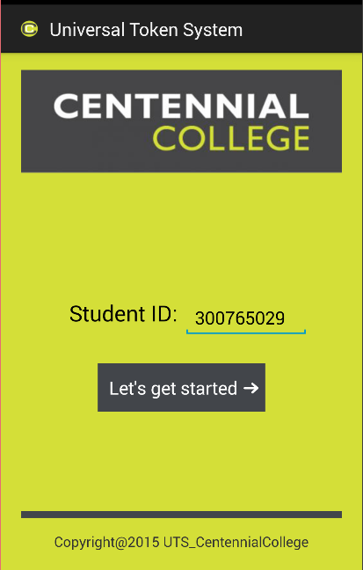

**List of Campuses:**

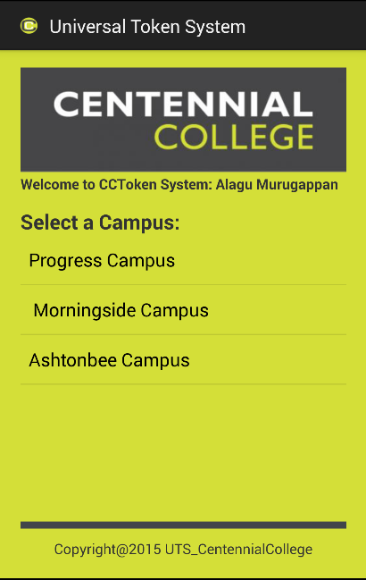

**List of Departments:**

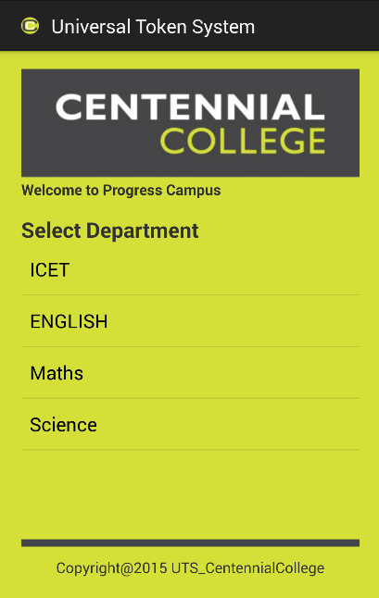

**Generate Token:**

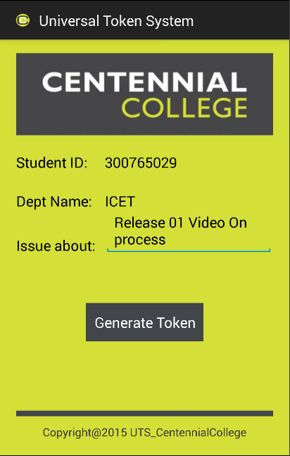

**Token Information:**

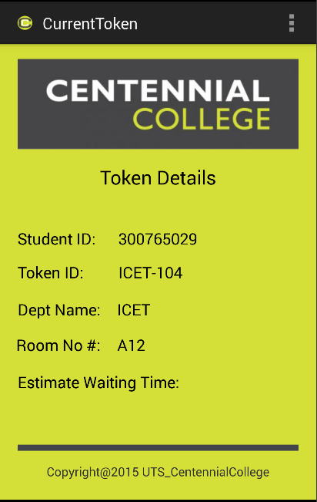

**Web Application for CURD Operations:**

**Admin Functionality Backend:**

1. **Student CURD Operations:**

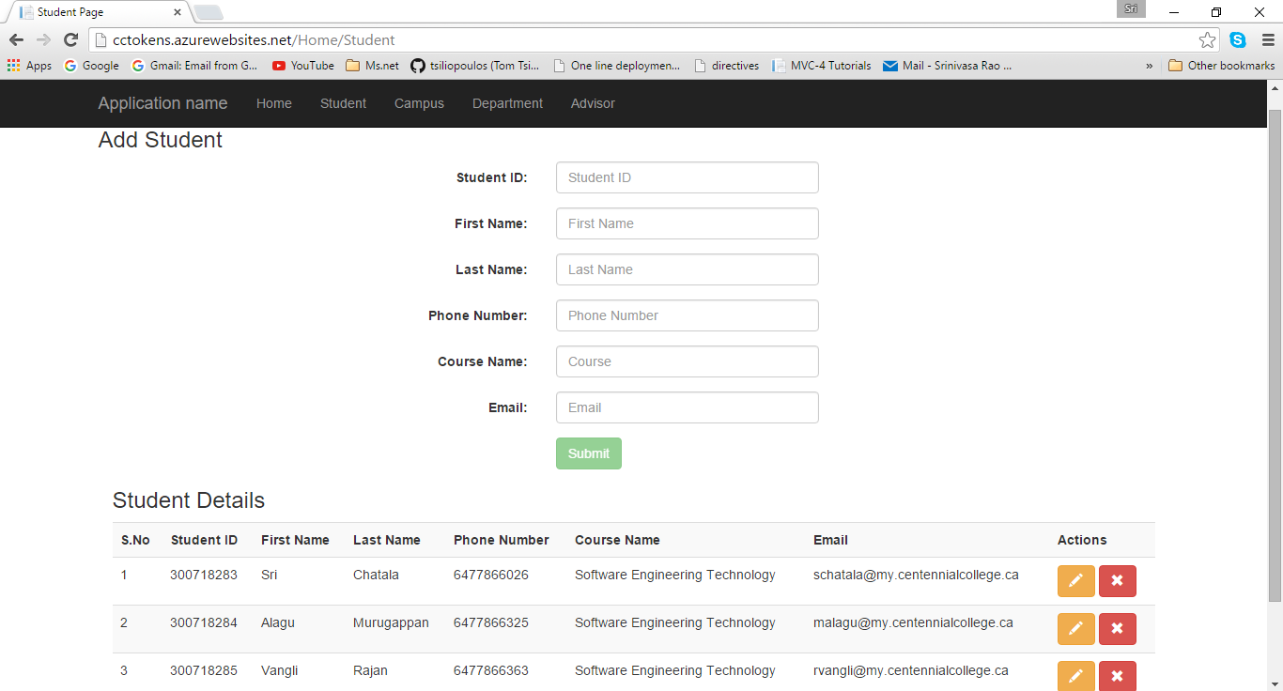

1. **Campus CURD Operation:**

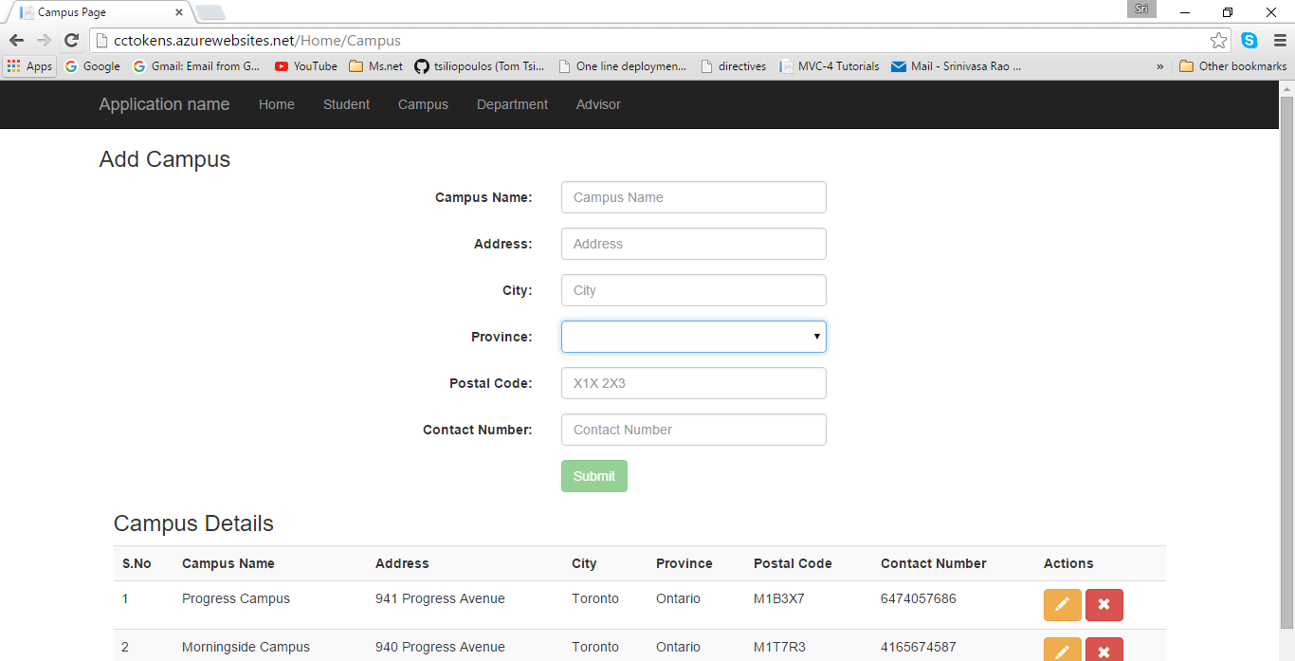

1. **Department CURD Operations:**

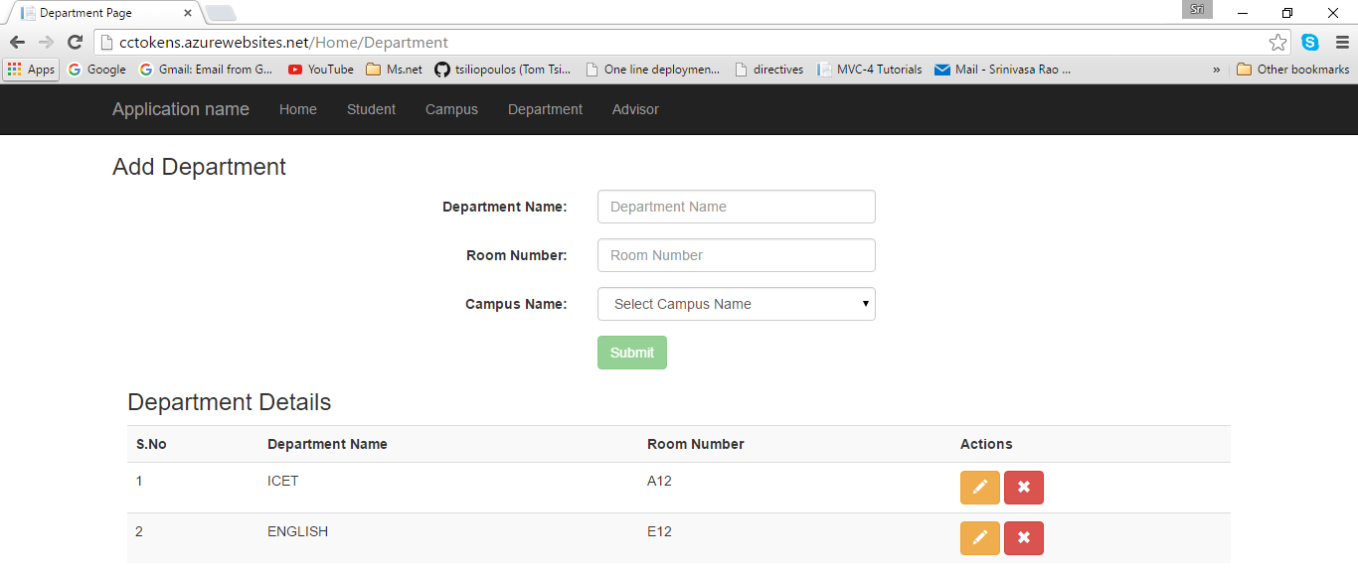

1. **Advisor CURD Operations:**

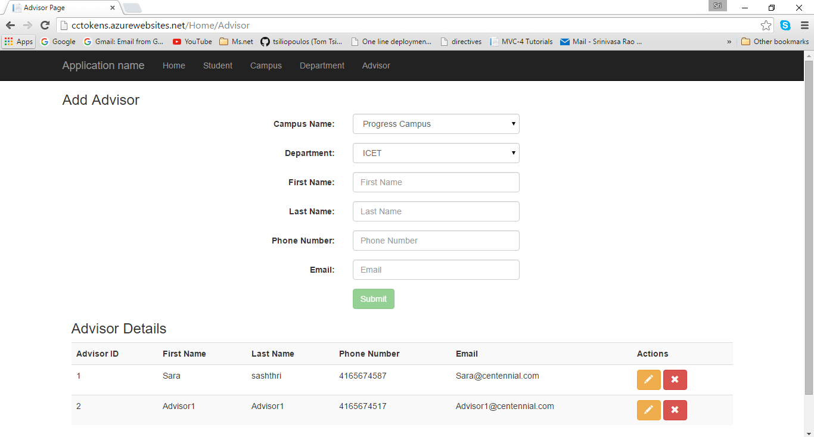

# **Release 01: Database Diagram**

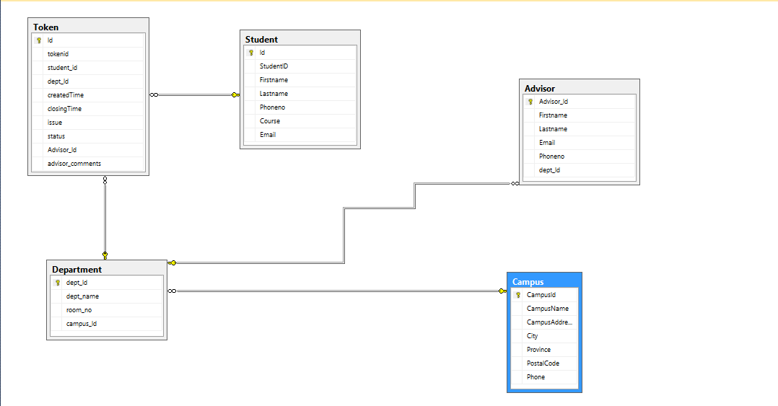

# **Release 01: Video**



# **Release 01: GitHub Repository URL**

<https://github.com/COMP313Team4/UniversalTokenSytem-AndoridApplication>